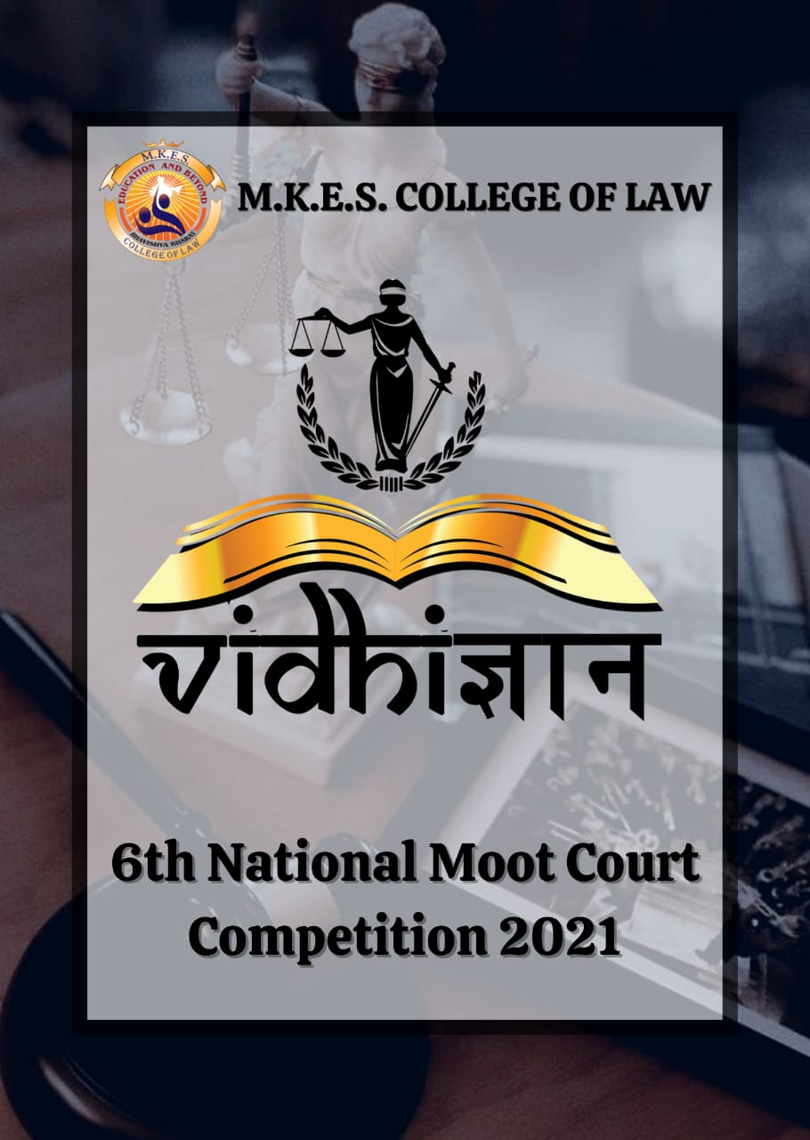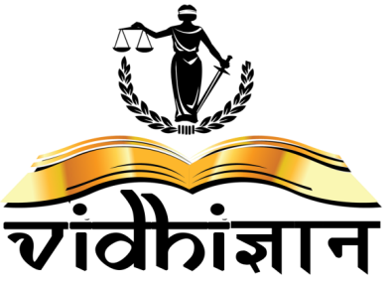

MALAD KANDIVALI EDUCATION SOCIETY’S
M.K.E.S. COLLEGE OF LAW

ABOUT OUR COLLEGE

Our philosophy on education is driven by our mission of providing integral and transformational education to our students. We firmly believe that education must not be limited purely to academic learning. At M.K.E.S, our focus is to develop all faculties of an individual to ensure Holistic Development, Mental Education to develop high levels of concentration, Vital Education for the development of one's character, Physical Education for team building and collaboration, and Spiritual Education for the growth of consciousness and the development of values.

Our Vision Bhavishya Bharat
Education for the youth
Education for all
Education for the future of our country
Quality Policy

‘We at M.K.E.S. College of Law are committed to impart quality education to youth, enabling them to develop right attitude, professional competence and inculcating right ethical values.’

ABOUT VIDHIGYAAN

‘VIDHIGYAAN’ is a law fest hosted and organised by the students and faculty of M.K.E.S College of Law. ‘VIDHIGYAAN’ provides an ideal platform for the students of various colleges to showcase their talents.

It provides an opportunity for students to come together, interact, and get motivated with the experience gained through Participation & Competition. It endeavours to bring together the creativity, intellect and wackiness of youth.

We strongly believe that there is a bit of Art in every heart &‘VIDHIGYAAN’ helps to unleash it. We will strive to make this year’s ‘VIDHIGYAAN’ a big success & attract great participation. ‘VIDHIGYAAN’ shall create history with great success and blossom not only qualitatively but also quantitatively.

VIDHIGYAAN will be hosting legal events to enhance the participant’s competitive spirit in a multifarious aspect. This year we, at VIDHIGYAAN, will be hosting only our National Moot Court competition. Our participants and their performance-oriented participation is the reason that VIDHIGYAAN exists and grows by every passing year.

INTRODUCTION
Mooting being an integral part of a student’s life in law school, to hone the talent and skills of young mooters who have only started with their journey in law, M.K.E.S has endeavoured to provide them a suitable platform with this moot court competition.
We at M.K.E.S believe in the strength of the non-conventional methods for imparting legal knowledge and mooting being an integral part of this method, offer to the law students the art of persuasion and application of the laws to real facts, without having to gain such experience at the risk of inadvertently damaging a real client’s interest.
After the success of the last 5 National Moot Court Competitions, our Team Vidhigyaan is organizing the 6th National Moot Court Competition this year, which is an attempt to offer students with fair opportunities of learning as it serves as a concurrence of the academic appraisal with pragmatic sensibility.
RULES AND REGULATIONS

ONLINE MODE OF COMPETITION
Google Meet/Zoom Meetings

LANGUAGE
The Competition shall be held in English only.

ELIGIBILITY
The Competition shall be open for the students who duly enrolled and are pursuing an integrated 5 years or 3 years Law Program in India from an institution recognized by the Bar Council of India in the academic year 2020-21.

REGISTRATION
Registration form duly signed by participants in soft copy to vidhigyaanmkes@gmail.comin order to provisionally secure their participation in our event.

REGISTRATION FEES
Rs. 800 /- per team payable at the time of registration for Law Colleges.
Teams must register themselves latest by 20th June, 2021 subject to changes and extension. GENERAL NOTE: Each college shall send only one team which shall comprise of Minimum Two and Maximum three members. This number cannot be modified under any circumstances.
MEMORIALS

The Memorial shall consist of following: -

- Cover page | VI. Statement of issues
- Table of contents | VII. Summary of pleadings
- Index of authorities | VIII. Argument advanced
- Statements of jurisdiction | IX. Prayer
- Statement of facts

- Each team shall consist of two speakers and one researcher. Teams are to notify which members are the respective speakers and researcher. No change of speaker to researcher or vice –versa shall be permitted except upon application to the Organizing Committee.
- The Memorials shall be typed on A4 size on one side paper with margin 1.5 inches from left side and (1) one inch from the other sides.
- Arguments must not exceed 20 (twenty) pages
- Font: - Times New Roman.
- Font size: - 14 and for footnotes 10.
- Line spacing: 1.5
- The memorials shall be submitted via online mode neatly in 2(two) copies i.e.1 (one) from petitioner’s side and1 (one) from respondents’ side.
- The memorial submitted will not be returned.
- Page numbering should be at bottom middle of each page.
- Covers must be placed on briefs as follows:
Petitioner: - Blue colour.
Respondent: - Red colour.
- Identity of the institution shall not be revealed anywhere in the memorial. Instead code numbers allotted to the students should be mentioned. Violation of these provisions shall result in penalties including disqualification. The decision of organizer shall be final in this regard.
- The written memorial shall be in accordance with the High Court rules.
- Each team participating in the Competition must prepare a Written Submission on behalf of the Petitioner/Applicant/Plaintiff and on the behalf of the Defendant/Respondent.
- A Written Submission shall be identified solely by the Team Code assigned to the team. The Written Submission shall not, in any way, disclose any fact pertaining to the identity of the team or members.
- Each team must send its memorial via mail in PDF format, latest by 28th June 2021, 11:59 P.M., the memorials shall be mailed on vidhigyaanmkes@gmail.com with the subject of the mail being “Memorial Submission V6-2021– ‘Team Code’”. Late submission of memorials will result in loss of marks for memorials unless any exemption is finally claimed
In case the subject is not as prescribed, memorials shall be deemed to have not been received and the Organizers shall not be responsible for any delay and default.
4. The file names of the electronic copies of the memorial must contain only the team code and the side being represented in the following format.

PLAGIARISM
Participants must refrain from using same language or copying from other's memorials and other sources. Even use of publicly available information must be accompanied by proper citations. These rules shall apply to all parts of the memorial and not just the Pleadings and Prayer. Failure to comply with this rule may result in the guilty participants being debarred from mooting in Vidhigyaan 6thNational Moot Court Competition (Online), 2021. The Organizing Committee in consultation with the memorial judges will take a final decision regarding determination of cases of plagiarism and penal measures for such action.

STRUCTURE OF THE COMPETITION
- The Moot court Competition shall comprise of following rounds:
  - Preliminary Rounds: Each team will have to present both the sides i.e. Petitioner/Plaintiff or Respondent/ Defendant in this round. The top eight (8) teams, based on the cumulative score of memorials and preliminary rounds shall qualify for the quarterfinals.
  - Quarterfinal Rounds: The top eight (8) teams from the Preliminary Round shall proceed to the quarterfinals. This will be a knockout round; hence winners will be decided on the basis of courtroom win. The draw of lots will take place after this round.
  - Semi - Final Round: The winning 4 teams from the quarter finals shall proceed in thisround. This round will again follow the knockout rule. The draw of lots will again take place after the competition of this round.
  - Final Round: The winner from each court room fixture i.e., 2 teams from the semi –final round shall proceed to this round.
- Each team will have a team code (designated during draw of lots). Each team shall be assigned with a team code decided by the Organizing Committee of Vidhigyaan. Team shall use their team code for identification purpose. Name of the participants should not appear on or within the written submissions. Signature pages are prohibited.
- After the virtual orientation of the teams, the draw of lots shall take place and the team has to argue on behalf of the side in accordance with the draw of lots, (the Petitioner / Applicant/ Plaintiff or the Defendant/ Respondent) in the preliminary round.
- In case of tie, highest memorial marks will be taken into consideration to decide the winner.

ORAL SUBMISSIONS
- The oral rounds shall be conducted online on a live video conferencing platform.
- The language to be used in the oral rounds is ENGLISH.
- As specified hereinabove, each team shall have two speakers who shall further divide the oral submissions between themselves.
- At no point of time during the Competition, any speaker shall reveal their identity.
- At the commencement of each round of Oral Submissions, each team shall notify to the Court Officer the division of time between the two speakers. Further, each team must notify to the Court Officer the amount of time that the team wants to reserve for their rejoinder / sur -rejoinder. A maximum of five (5) minutes may be reserved for the rebuttal/ sur-rebuttal.
- Five (5) minutes and Two (2) minutes before the completion of the allocated time for each speaker, there will be a warning bell, and at the completion of the allocated time for each speaker there will be a final bell.
- In case a speaker continues to speak after the completion of his/her specified time, the additional time which he/she consumes will attract negative marking at the discretion of the judges. The judges shall have all the rights to grant opportunity to give rebuttal or sur -rebuttal and to allocate additional time.
- During oral submissions, the participants cannot submit to the court any material containing pictorial representation whatsoever. Further, the participants are not permitted to make any audio/visual representation nor allowed to use any online search engines during their submissions.
- If at any instance a submission is made with any material in violation of rules and if any picture, sketches, photos, cartoons, caricatures, audio film, video film, projector - slide or a computer -generated image is used or submitted or presented to the court, the teams shall be subject to disqualification.
- The Best Speaker Award shall be determined based on the individual aggregate score of the Speaker taken only from the Preliminary Rounds.

PRELIMINARY ROUNDS
- Each team will have a maximum of 20 (15+5) minutes to present its oral submissions.
- All the participating teams are expected to carry with themselves case laws and authorities which they intend to refer along with their own copies of memorials.
- The participants during the course of oral submissions will not be permitted to make any audio/visual representation nor will they be allowed to use personal computers, laptops and any other technical or mechanical device.

SCORING CRITERIA FOR PRELIMINARY ROUND
The Marks shall be given as per following criteria for preliminary round:
Written memorials | 15 Marks
Oral arguments | 15 Marks
Time adherence | 10 Marks
Overall performance | 10 Marks
Total | 50 Marks
Time allotted | 20 Minutes

FINAL ROUND
In the final round each team will get 30 (25+5) minutes to present the side allotted to them.

SCORING CRITERIA FOR FINAL ROUND
For final round the marks shall be given as per following criteria: -
Application of law relevant to the case | 20 Marks
Advocacy and presentation | 15 Marks
Court etiquettes | 10 Marks
Answers to court questions | 15 Marks
Interpretation of and use of facts | 10 Marks
Research relevant to the case | 10 Marks
Time adherence | 10 Marks
Overall performance | 10 Marks
Total | 100 Marks

*The decision of the judges as to the assessment of oral submission shall be final.

TEAM COMPOSITION

- Each college shall send only one team which shall comprise of Minimum Two and Maximum three members. This number cannot be modified under any circumstances.
- Each team which consists of three members shall comprise of Two Mooters and One Researcher (Moot Court Competition). Each team should identify such speakers and researcher at the time of their registration. The researcher won’t be required nor allowed to speak except under special cases and only with express permission of the organizers/Judges. If a team consists of Two Members, then both of them shall be mooters only.
- Each team will be given a unique team code which will thereafter be the identity of the team and its members.
- During the course of the competition, the identity of the college must not be disclosed to the judges or to any other person. Any such discloser shall lead to disqualification. The decision for the same shall be at the discretion of the organizers.

DRESS CODE

The dress code for participants shall be as prescribed by the Bar Council of India. (Gowns and bands prohibited)

AWARDS

MOOT COURT COMPETETION
PERFORMERS | PRIZE
Winner | Rs. 20,000/-  & Accompanying Certificate
Runner-up | Rs. 12,000/-  & Accompanying Certificate
Best Speaker | Rs. 2,500/- & Accompanying Certificate
Best Memorial | Rs.1,500/- & Accompanying Certificate

Certificate of Participation will be awarded to all participants.

DATES TO REMEMBER

- Date of Competition 3rdand 4th July 2021.
- Last date for Registration 20th June2021.
- Submission of Memorials 28thJune 2021.

NOTE:

EXCHANGE OF MEMORIALS SHALL TAKE PLACE BY 30th JUNE, 2021. THEREBY, SUBMISSION OF MEMORIALS SHALL TAKE PLACE BY 28th JUNE, 2021, FAILURE OF WHICH MAY LEAD TO MARKS DEDUCTION.

FOR ANY QUERIES, PARTICIPANTS ARE WLCOMED TO CALL OR EMAIL.

STUDENT COORDINATORS:

Shourya Tripathi: +91 9892427159
Shruti Singh: +91 9867449872

PROFESSORS IN-CHARGE

Prof. Varsha Vyas: +91 7666355365

Prof. Nikhil Rote: +91 8670074356

Official Email ID: vidhigyaanmkes@gmail.com

